**What Are The Alternatives?** Third Quarter 2016

***A Private Funds Primer***

**Preface**

Over the past three years, EIS has worked with qualified[1] colleagues and family members who have made more than 200 commitments to our private funds strategies. These so-called “alternative” investment strategies include hedge funds, private equity, private debt, and specialty funds managed by Neuberger Berman within our $35 billion[2] alternatives business.

As with most asset classes, private funds have an investment language all their own. Private funds’ distinctive investment processes, risk and reward considerations, and performance measures can present a steep learning curve for traditional equity and fixed income investors. Indeed, private funds often focus on institutions for which they were originally developed.

In this edition of *EIS Quarterly*, we summarize some of the fundamental topics that we have discussed with qualified colleagues evaluating Alternative strategies and potential allocation within portfolios.

**What Are the Alternatives?**

As the name suggests, Alternatives generally refer to investment classes that are less conventional than traditional investments. Simply put, these are investments that represent *alternatives* to stocks, bonds, mutual funds, exchange-traded funds, bank products and other, more mainstream investment classes.

Simplifying complex definitions, we use “Private Funds” and “Alternatives” as synonyms. In the report, we focus on private equity-style alternatives funds that are:

1) generally illiquid, with strategies designed for investment horizons of up to a decade or more, and

2) restricted to investors with net worth, liquidity, and experience required by applicable regulations.

Alternatives as a general class of investment also can include *liquid* fund investments (“liquid alternatives”) as well as real estate, commodities and other types of investments and asset classes — each a potential topic for future discussion.

**Organization**

Generally speaking, mutual funds are investment companies formed as corporations. By contrast, private funds typically are organized as limited partnerships, commonly referred to as LPs. Private funds often are formed to enable qualified investors (typically limited partners) to pool their capital for the purpose of making specific types of investments under the direction of a fund manager (typically the general partner.)

The partnership structure common to private funds enables a broad range of investment activities and strategies compared to mutual funds, ETFs and other pooled vehicles. Importantly, the LP structure enables *reduced* regulatory oversight, reporting, and disclosure requirements, thus providing an element of privacy that other investment vehicles may lack.

**Tax Reporting**

Structured as limited partnerships, private funds generate K-1s (officially Schedule K-1s or Form 1065s) for each investor or so-called fund **subscriber**. Investors in private funds receive K-1s for each tax year during which they are “in the fund,” for each LP in which an investment is made, and for each person or entity investing (e.g., joint account, IRA, Trust, etc.)

Professional tax preparers often assist private fund investors with K-1s. Broadly speaking, multiple K-1s can be “added together” when preparing income tax returns. Nevertheless, partnerships may provide K-1s *after* mid-April tax deadlines. This, in turn, may necessitate filing an automatic income tax extension by mid-April (IRS Form 4868) and paying estimated taxes – a manageable process but one that can be new to traditional investors.

**Qualifications**

To invest in Neuberger Berman private funds in the U.S., individuals – including employees, family members, or clients – must be so-called Qualified Purchasers (“QP”) with $5 million or more in investments. They ***also*** must be Accredited Investors. Employees who are directly engaged in portfolio management or research for one of our pooled vehicles, or who lead a firm-wide operating or policy function, or meet certain other requirements may also be eligible. (See Appendix for details.)

**Range of Private Funds**

Within NB Alternatives, our private funds include hedge fund strategies, private equity and private debt strategies, commodity, quantitative, and specialty strategies. A high level summary of our capabilities, representing $35 billion under management, can be found at NB Alternatives.

**Private equity** and **private debt** funds comprise a majority of our alternatives strategies – roughly $25 billion of capital presently invested or committed for investment over the coming few years. Private equity and private debt funds generally invest in the equity and debt of *private* companies, as opposed to equity and debt investments in *public* companies.

A few Neuberger Berman private funds invest in specialty private equity-style strategies, such as retail brand royalties, residential real estate loans, and hedge fund minority ownership stakes, for example. For the purposes of this *EIS Quarterly*, we refer to all such strategies simply as private equity funds.

Whether in equity or debt, private equity fund investments can be made one company at a time as “**direct investments**,” or in multiple companies at once, known as “**fund investments**.” These investments, essentially multiple investments made in a single bite, can be made with new private funds, and are known as **primary investments**. Fund investments can also be made in pre-existing funds through so-called **secondary investments**.

Finally, **co-investment** funds typically invest alongside other private equity or debt investors who may be leading an investment transaction.

**Purposes of Allocation to Alternatives**

Private equity funds operate in the same overall business and economic environment as public investors. Private equity-backed companies themselves may be household-name businesses, such as Burger King, Hertz, Dell, Cinemark Theaters, and Univision, to name a few.

However, given PE funds’ confidentiality and long-term investment horizon (recall, investors generally commit capital for a decade or more) private funds can take advantage of a wider range of investment capabilities, information, and opportunities than public investors.

How might this enhance an investor’s portfolio?

**Risk & Reward**

**Illiquidity Premium** Private equity investment returns can be higher than comparable public returns, and potential reward for investors’ acceptance of private fund illiquidity can be attractive. Arguably, investors require a premium return to compensate for illiquidity. For investors who can accept such long-term investment requirements and corresponding lack of access to their capital, “illiquidity premium” can provide attractive risk-adjusted return from private funds.

**Private Information, Access Premium** Non-public information, and access to the Board, management, and operations of private companies can help enhance the investment success of private fund managers. Moreover, private fund managers often strive to improve the operations, capital structures and strategies of portfolio companies themselves. These and other information, access and execution “tools” help define the private equity asset class and its return potential.

**Potential Risks and Considerations**

Illiquidity is among many risk considerations for private fund investors. A wide range of redemption restrictions is standard across hedge, private equity and specialty funds. An investor’s ability to redeem invested capital without penalty – or at all – can be limited. Even commitments for future investments can be difficult or impractical to cancel, in turn giving rise to secondary markets for fund investments, as described above.

Finally, unlike most equity and debt of publicly-traded companies, holdings in private companies may not be easily or precisely valued. Private company valuation methods can be less precise and more time-consuming, particularly valuing portfolios containing hundreds or more individual company investments. Accordingly, private fund investment values are often provided quarterly – an investment consideration in its own right.

**Investment Periods & Fund Lifetimes**

Private equity funds typically invest committed capital over 3-4 years, referred to as the **investment period**. Funds can call for investors’ capital throughout this period, roughly *as* investments are actually made by the fund managers. Fund subscribers should be familiar with the anticipated timing of fund investments, in part so that cash committed to a fund can be made available if and when needed. Once the initial investment period and possible extensions have passed, typically no new investments or capital calls can be made by the fund.

**Capital calls**,also known as **drawdown notices**,generally arrive as email notifications and provide at least 10 days’ advance notice for required wire transfers to the fund administrator. Many private funds enable automatic wire transfers from an investor’s investment account, if desired, to streamline capital call processes that can occur several times per year. Funds must be available in any linked account from which automated wire transfers to originate.

1 Hypothetical PE Fund Lifecycle



During the investment period, fund managers often **recycle** or re-invest income or other distributions that may result from initial fund investments. Each type of fund – equity debt, hedge, etc. – and each specific fund will outline its practices in a **private placement memorandum** or similar document.

The **realization** phase of a private fund, and annual extensions that can last 1-2 years or more, allow fund investments to run their intended course, distributing potential investment proceeds to fund investors if and roughly as they occur. A broad range of investment outcomes – from M&A and IPOs, to securities sales, interest or royalty income, etc. – can trigger investment realizations for fund subscribers. It all depends upon the strategy employed, management execution, and fund outcomes achieved.

**Drawdowns**  The multi-year investment period, and even longer-term realization period common to private equity funds, produces a so-called **J-curve** depicting cash flow into and from the fund. The rate at which a fund calls for investor capital, and the rate at which realizations are distributed back to investors, can vary widely.

The **maximum drawdown** refers to lowest point in the J-curve, typically during the first few years of the fund, when investors experience the largest total cash outlay.

Figure 2 - Hypothetical J-Curve

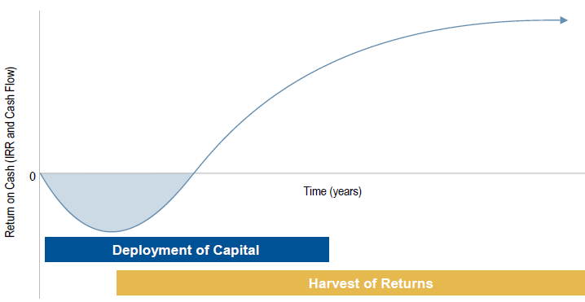

A typical maximum drawdown can range from 50% - 80% of an investor’s total capital commitment, after which capital returned *to* investors can reduce the balance of total cash outlay, contributing thereafter to positive cash and investment returns.

**Allocation & Suitability** Our Investment Strategy Group (ISG) recently updated our 2016 Portfolio Guidelines to include sample allocation targets of 5% to 15% for Alternatives as an overall asset class. Individual fund investments typically help diversify an overall allocation to Alternatives. A wide range of allocation targets between 0% and 40% can apply based upon individual client circumstances.

An allocation to Alternatives is by no means appropriate for all investors – not even all Qualified Investors. Yet guidelines help to better evaluate the role that Alternatives can play as part of a diversified investment portfolio.

Each client considering an allocation to Alternatives through a private fund must complete a Suitability process with their investment advisor. Suitability helps assure that each private fund may be appropriate for each investor’s circumstances, and typically restricts individual investment to not more than 5% - 10% of one’s liquid net worth.

**Tax Considerations** Private funds each have their own tax character, depending in part upon the type and mix of investments made within each fund. As a general rule, interest income, dividends, royalty streams, short- or long-term gains, etc., that individual investments can generate are passed through to investors. (As a reminder, funds are typically organized as limited partnerships, enabling the pass-through of gains, losses and other forms of taxable activity to investors themselves.)

For example, a private equity fund might employ a strategy that targets long-term capital gains. If achieved, in turn this would cause “realizations” that are taxable as long-term gains to fund investors themselves. By contrast, a private debt fund might pursue a strategy that targets a blend of interest income and capital gains. In this case, resulting distributions to *taxable* investors would reflect the combination of income and gains experience within the fund itself.

IRA, Roth IRA, and other *tax-exempt* investors in private funds should consider the tax treatment applicable to their respective account type. As described above, the pass-through of fund distributions establishes the initial character of income, gains, losses, etc., from the fund. Thereafter, however, the ultimate tax treatment of distributions to an individual depends upon the nature of, and rules surrounding, the tax-exempt account itself.

**Costs & Fees** For employees and family members qualified to invest in our private funds, the firm’s EIS program waives all fund **management fees** and incentive fees or so–called **carried interest**. Operating costs remain part of the expense structure of the funds themselves and impact all fund investors ratably.

For arm’s-length, non-EIS investors, private equity funds typically combine an annual management fee of 1% - 2% with additional carried interest in the investment performance of the fund. Carried interest fees serve as extra incentives for fund managers. Carried interest fees generally are tied to fund performance that may be achieved in excess of a threshold, called the **preferred return**.

Private funds fees can vary widely, often adjust as fund lifecycles progress, and are described in detail within the private place memorandum for each fund.

**Performance Measurement** Private equity-style fund performance is often represented using the I**nternal Rate of Return** (IRR) for the fund, typically both gross and net of applicable fees. Performance can also be described using the M**ultiple** or “realization multiple” both gross and net of applicable fees. The Multiple presents the ratio of (a) total distributions made *to* investors, to (b) the total paid-in capital *from* investors.

Because private equity funds typically invest committed capital over 3-4 years, the relationship between IRR and Realization Multiple is important to consider when reviewing fund performance. This is somewhat complex but extremely important to investor education.

**Fund Minimums** For qualified employees and family members, the minimum initial commitment to NB private funds available through EIS generally is $25,000. Non-employee client minimums can vary widely as a function of individual fund requirements, generally from $250,000 to $10 million.

**CANDIDATE TOPICS NOT INCLUDED:**

* Discussion of the types of NB private equity funds
* Discussion of the types of NB hedge funds
* Portfolio optimality using private equity (image)
* Building a portfolio of ‘rolling’ private funds
* ECI / UBTI as may impact IRA and non-U.S. investors
* Actual historical NB fund performance
* Client reporting

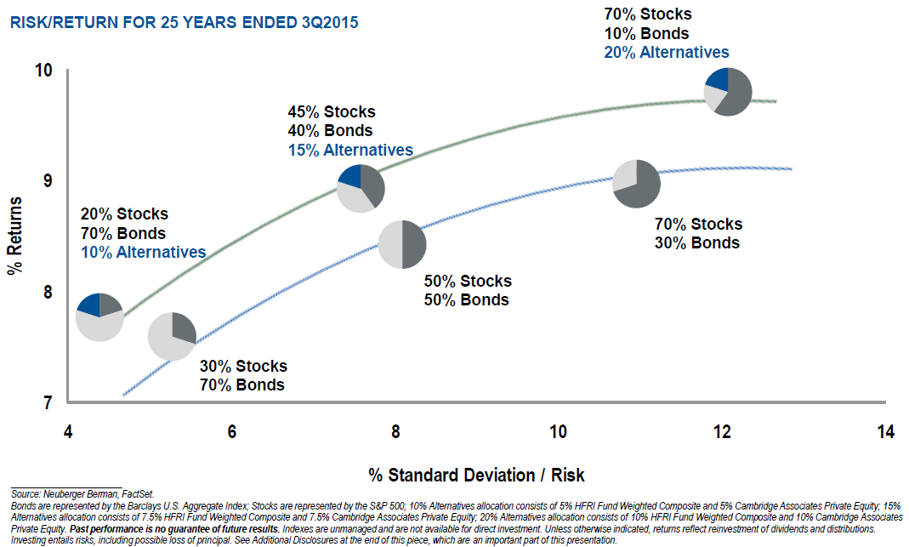

**APPENDIX**

***Qualifications***

All U.S. investors in NB Private Funds must be “accredited investors” **and** “qualified purchasers.” If you do not meet the “qualified purchaser” or “qualified client” standard, you may still be eligible if you are directly engaged in portfolio management or research for one of our pooled vehicles, lead a firm-wide operating or policy function, or meet certain other requirements (see below).

***Accredited Investor***

As defined in Rule 501(a) of Regulation D under the U.S. Securities Act of 1933, as amended, the term “accredited investor” includes a (a) natural person whose net worth (which excludes the value of the person’s primary residence and any indebtedness that is secured by the person’s primary residence, except for the amount of indebtedness that is secured by the person’s primary residence that exceeds, at the time of the sale of the securities, (i) the estimated fair market value of the primary residence or (ii) the amount of indebtedness outstanding 60 days before the sale of securities, other than as a result of the acquisition of the primary residence) either individually or jointly with such person’s spouse, at the time of such person’s purchase, exceeds $1,000,000 or (b) natural person who had individual income in excess of $200,000, or joint income with such person’s spouse in excess of $300,000, in the previous two calendar years and reasonably expects to reach the same income level in the current calendar year.

***Qualified Purchaser***

As defined in Section 2(a)(51)(A) of the U.S. Investment Company Act of 1940, as amended, the term “qualified purchaser” includes a natural person who owns $5,000,000 or more in “Investments”. In making this determination, subtract the amount of any outstanding indebtedness incurred to make the Investments. The term “Investments” includes cash and cash equivalents held for investment purposes, securities, real estate held for investment purposes, commodity futures contracts, options on commodity futures contracts and options on physical commodities traded on or subject to the rules of a major commodities exchange, and held for investment purposes, and financial contracts, including swaps and similar contracts entered into for investment purposes.

1. *Neuberger Berman requires that all private fund subscribers be Accredited Investors and Qualified Purchasers. See* [*myNeuberger*](http://home.nb.com/departments/HR/Pages/EIS-private_funds.aspx) *for details and Other Qualifications.* 
2. *Citation for latest AUM from firm brochure or IQ. As of March 2016, including commitments in the process of documentation.*